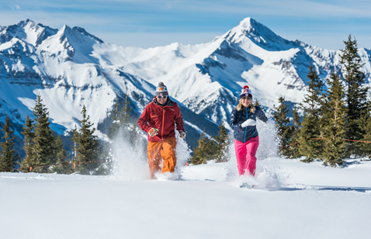 **Blue Ridge Western Carnival!**

**TELLURIDE, Colorado**

**February 6-13, 2021**

**Don’t miss out on the epic winter fun, legendary mountain views, and Blue Ridge Ski Council party events with your friends!**

**Price: $2155 per person, double occupancy (add $629 for single)**

**Package includes:**

**\*Roundtrip air: DCA/Montrose, CO, including tax [deduct $635 for no air]**

**\*Roundtrip transfers: Montrose Airport / hotel (68 miles) w/grocery & liquor stop**

**\*7 nights lodging at the Mountainside Inn (hotel w/kitchenettes), incl. mid-week full clean**

**\*5 of 10 day lift tickets [add $55 for 6 days; also senior discounts (65+), and 80+ ski free!**

**\*Wine and Cheese Welcome Reception /SuperBowl party [Feb 7th, 4-9pm]**

**\*On-mountain western BBQ at Gorrono Ranch [Feb 9th, 2-4pm]**

**\*Farewell dinner/dance party [Feb 11th, 6-10pm]**

**More Info on the Lodging:**

**\*Fagowees currently have 5 double rooms booked at The Mountainside Inn, oddly enough on the mountain side of the town of Telluride**

**\*The rooms have a queen and a twin bed (roommates could swap after mid-week clean)**

**\*Kitchenettes have a 2-burner countertop stove, microwave, fridge, toaster, coffee maker**

**\*Rooms have a shower (no tub)**

**\*There are coin laundry machines and ice and soft drink vending machines**

**\*Large outdoor hot tub by the river!**

**\*Walk to restaurants, shopping, the whole town.**

**\*Free parking if you’re driving there**

**\*Trip Advisor link:** <https://www.tripadvisor.com/Hotel_Review-g33667-d120041-Reviews-Mountainside_Inn-Telluride_Colorado.html>

**More Info on Air Travel:**

**\*Fagowees currently have 10 seats confirmed on American Airlines to/from Montrose, CO from Washington, DC Reagan National with a connection in Dallas**

**\* The flights:**

* **2/6 #2101 8:59a – 11:26a #5815 12:28p-1:55p DCA/DFW/MTJ**
* **2/13 #2321 10:50a – 1:59p #2445 3:05p-7:07p MTJ/DFW/DCA**

**More Info on Skiing/Riding:**

**\*Price above includes a 5 out of 10 day lift pass**

**\*Free Mountain Tours**

**\*Add $55 to upgrade to a 6-day pass**

**\*Age 65-79: Deduct $16 from package price for lift discount. Add $37 for a 6-day pass**

**\*Age 80+ skis free!**

**\*Deduct $395 for no lift ticket or if you have your own EPIC pass (or are 80+!)**

**\*If you buy an EPIC pass through Sportours (our tour operator), take $100 off the full package price.**

**-You’ll need the Full Epic Pass. Telluride is only a partner resort of Epic.**

**-Epic Pass now comes with free insurance coverage. See chart below:**

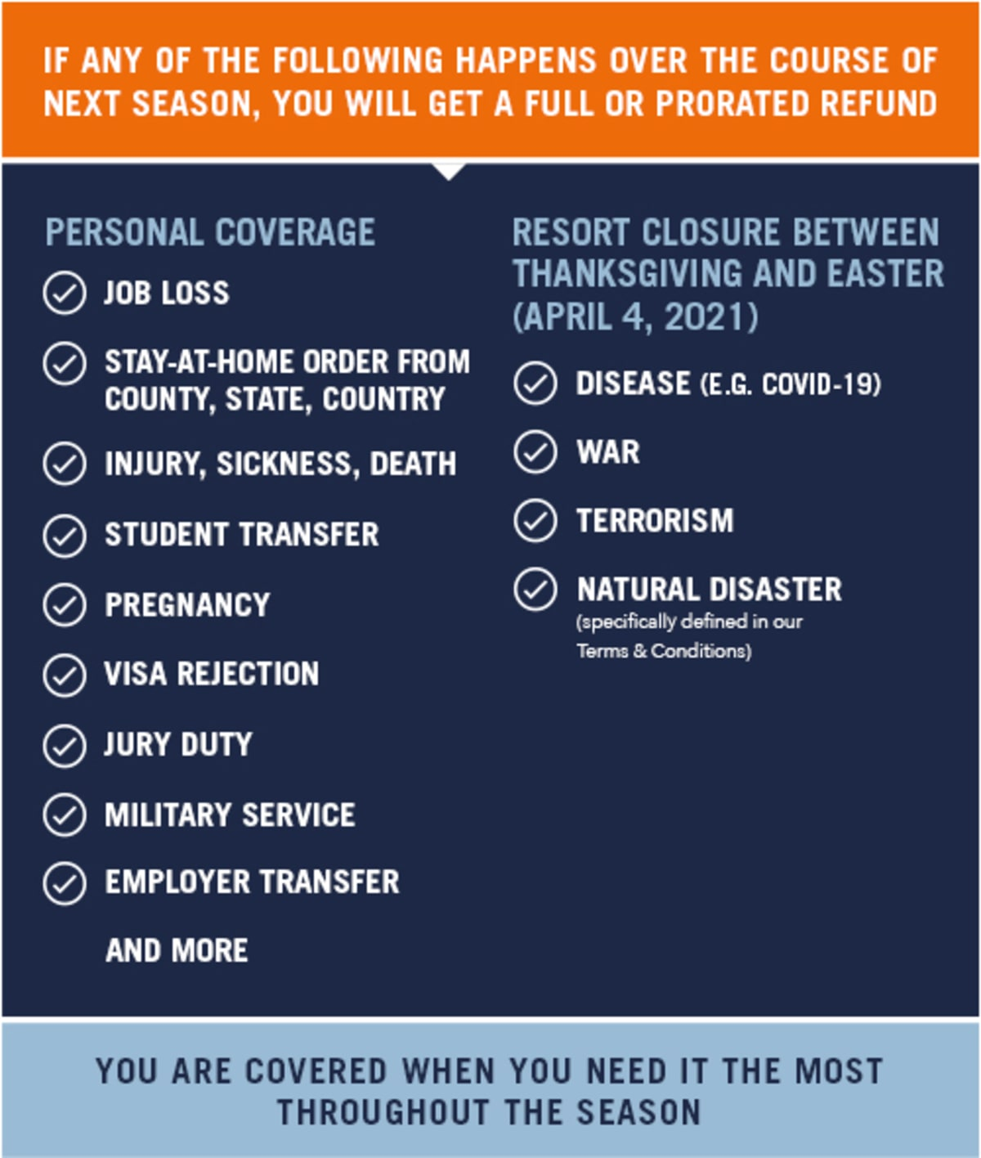

**\*See epicpass.com for more information**

**\*So yes, if you buy a Full Epic Pass through Sportours for $979, you get to deduct $495 from your trip price, and Liberty, Roundtop, Whitetail, and many other local ski mountains are on the Epic Pass now!!**

**Other Telluride Info:**

**\*USA Today Top 5 for Nightlife; Conde Nast Top 20 and Fodor’s Top 10 of Best American Cities for Foodies (imagine if you took the big cities out of those lists!)**

**\*Over 50 restaurants, bars, and breweries**

**\*Telluride averages over 300 days of sunshine and 300” of snow annually**

**\*There are not one, but three free gondolas anyone can ride. One is 200m from the hotel**

**- The gondolas run from 7am - Midnight**

**\*Lift 7 is also about a 200m walk from the hotel**

**\*Grocery and other shopping within walking distance**

**Other Available Winter Activities:**

**\*Snowshoeing, Fat Tire Biking, Sledding, Sleigh Rides, Nordic (cross country) skiing**

**\*Historical tours, Helicopter skiing, Ice Climbing, Winter Fly Fishing, Nastar racing**

**\*Horse Riding, Ice Skating, Snowmobiling, Museums, Day Spas**

**\*Stroll the Arts District and you can even take a variety of art classes**

**Payment Info:**

**\*Signup: $200**

**\*Oct 1st: $400**

**\*Nov 1st: $400**

**\*Dec 1st: $500**

**\*Dec 30: Final Payment**

**Sportours Cancellation Policies:**

**\*Airfare:**

* **Apr 2 – Dec 2: Fagowees may reduce block of seats without penalty**
* **Dec 3 – Dec 23: 0 to $100 penalty to cancel (depends how many cancel)**
* **After Dec 24: No refund**

**\*Lodging:**

* **Up to Nov 1: No penalty**
* **Nov 2 – Dec 30: 0 to 100% penalty to cancel (depends how many cancel)**
* **After Dec 31: No refund**

**\*If trip goes as planned, there is no refund for your late arrival or early departure**

**\*If trip goes as planned, there is no refund for components of package you did not use**

**\*Sportours not responsible for Force Majeure (circumstances beyond their control), including weather, although:**

**\*No Snow: Sportours will make every effort to find another destination or refund as much as possible of costs**

**\***TRIP CANCELLATION/INTERRUPTION INSURANCE IS RECOMMENDED**!**

**\*In the unlikely event of an excessive increase in one or more costs beyond the control of Sportours, participants may have to pay additional funds. Sportours will make every effort to recoup these costs and may be able to refund participants after the trip.**

**\*Fagowee Cancellation Policy:**

**- Before Nov 2: Full refund**

**- Nov 2 – Dec 30: $100 penalty**

**- After Dec 30: No refund**

**Get your $200 deposit in to Trip Leader Rich Kavanagh (check made out to “Fagowees”) at the meetings or mail to him at 601 Ford Rd, Deale, MD 20751. Online website payment should be available soon!**

**If you don’t want to put a deposit right now in this COVID environment, let Rich know your interest so far (**[**rem920@yahoo.com**](mailto:rem920@yahoo.com)**). We will be monitoring the virus closely and may elect to cancel to whole trip prior to the Nov 1st deadline for full refunds.**

** **